1.Counting Elements

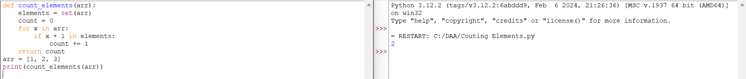

2.Perform String Shifts

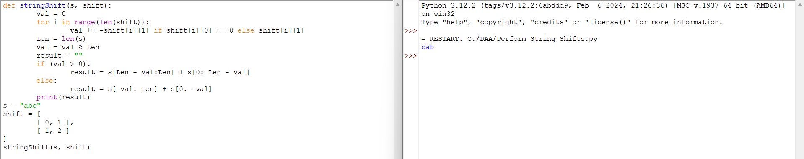

3.Leftmost Column With at Least a One

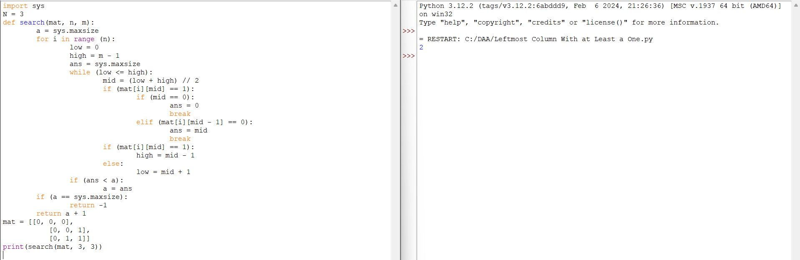

4.First Unique Number

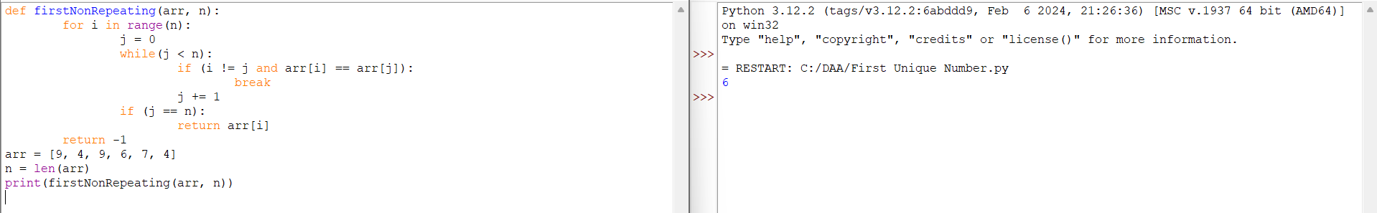

5. Check If a String Is a Valid Sequence from Root to Leaves Path in a Binary Tree

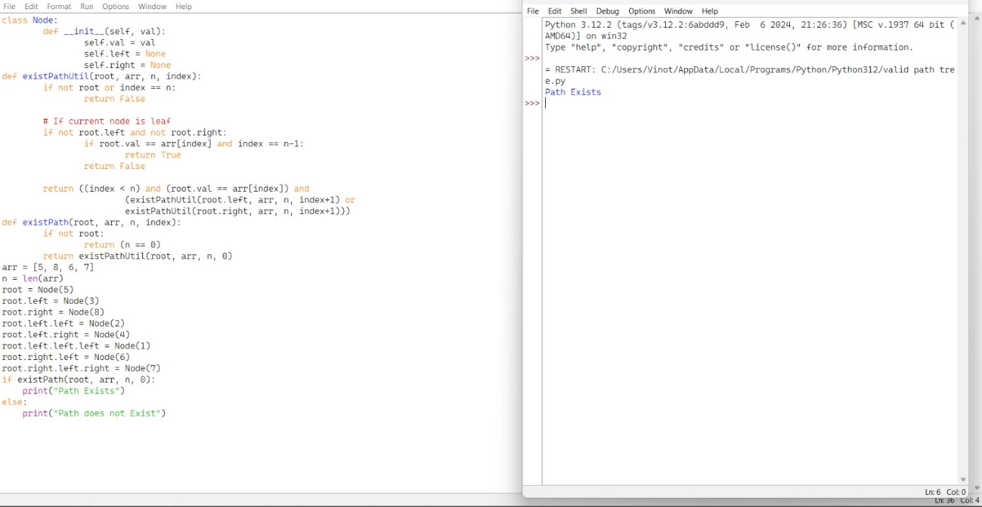

6.Kids With the Greatest Number of Candies

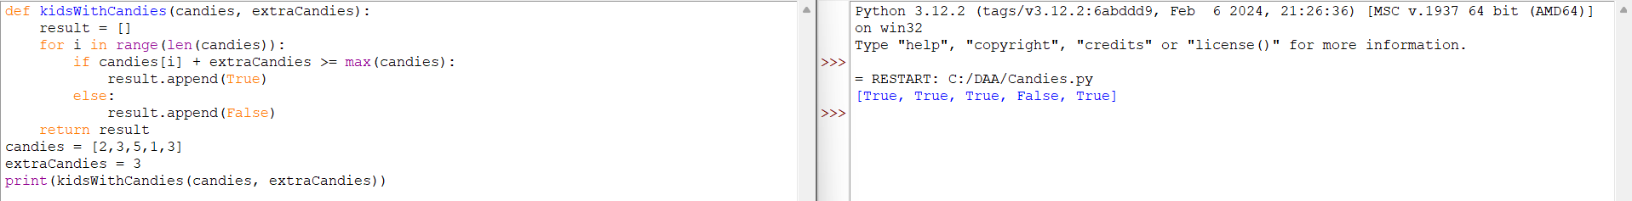

7.Max Difference You Can Get from Changing an Integer

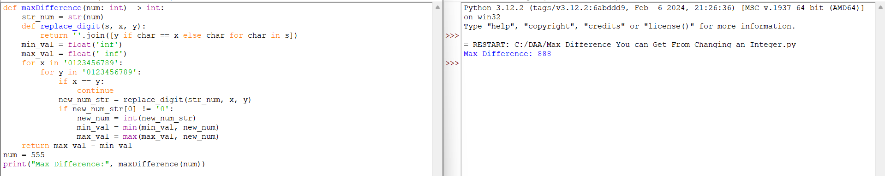

8.Check If a string Can Break Another String

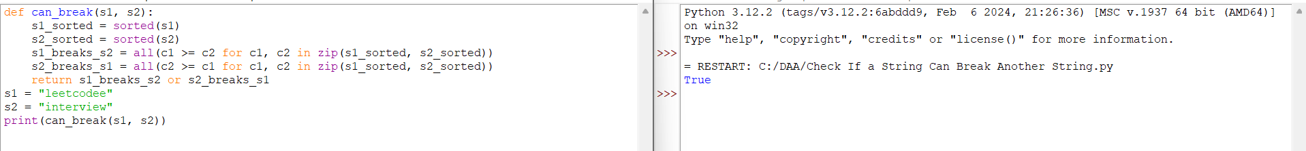

9.Number of Ways to Wear Different Hats To Each Other

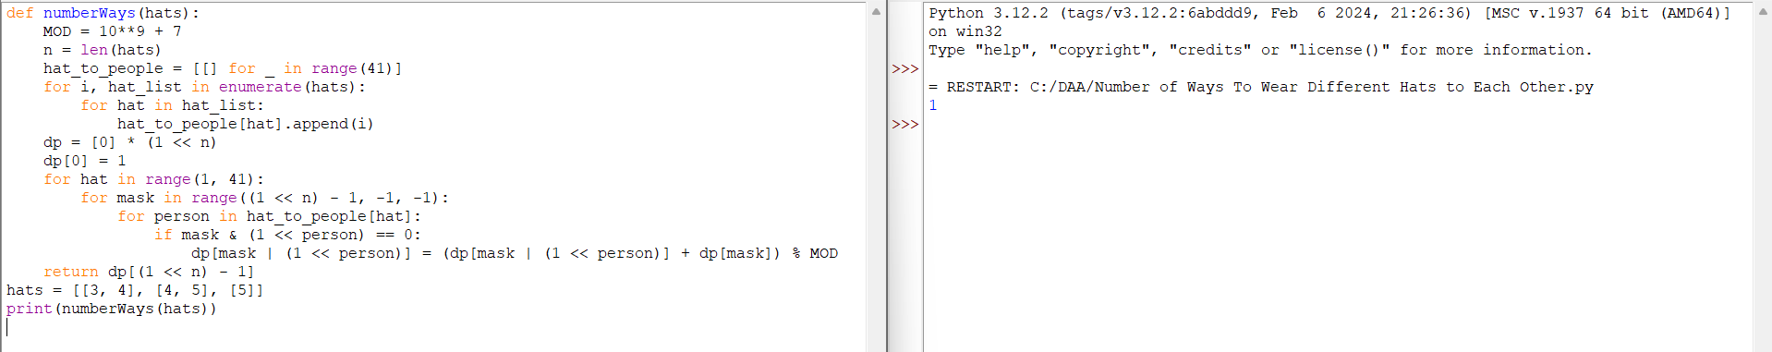

10.Next Permutation

